**(WD CSS & CSS3)**

**MODULE -** 2

**CSS & CSS 3**

**Submitted to :-**

**Mrs.Heena Malek**

**Submitted by :-**

**Ankita Sahu**

**1.What are the benefits of using CSS ?**

**Ans:-**

**C**

**SS (Cascading Style Sheets) is considered as one of the safest coding**[**methodologies for web development**](https://www.educba.com/career-in-web-development/)**, it also means that your website has more content than codes. One of the advantages of CSS is that CSS is very**[**helpful for Digital marketing**](https://www.educba.com/digital-marketing-tips/) **purposes where every promotion of your web page gives a chance to score a business.**

**So, more content than code formula with the help and use of CSS techniques are better for digital marketing and your business ultimately.Using CSS modularizes your websites in much the same way that programmers have been modularizing software code for year. Modular code in your website allows for greater design consistency and easier maintenance. CSS is the new standard and has been now for several years. It’s time to separate the structure of HTML and the presentation of CSS.**

* **There are three types of CSS which are given below:   
   > Inline CSS**

**> Internal or Embedded CSS**

**> External CSS**

**i) Inline CSS :-**

**Inline CSS contains the CSS property in the body section attached with element is known as inline CSS. This kind of style is specified within an HTML tag using the style attribute.**

**Example:**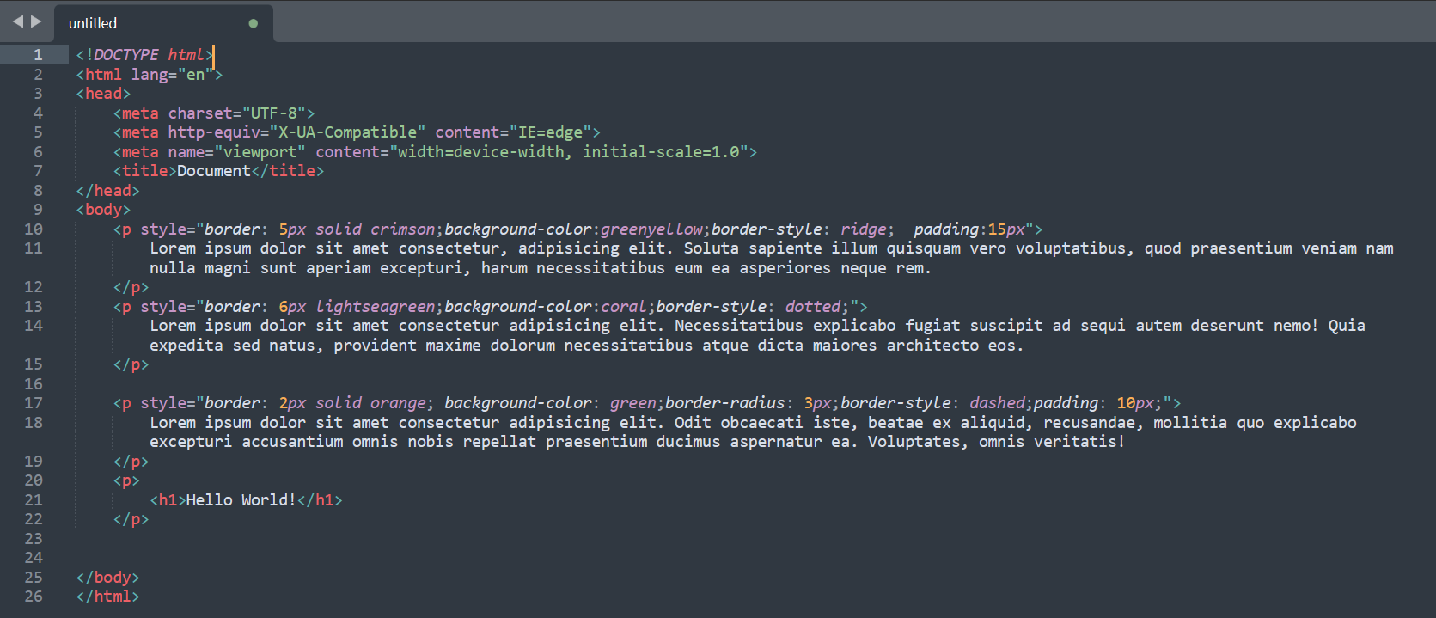

**Output:**

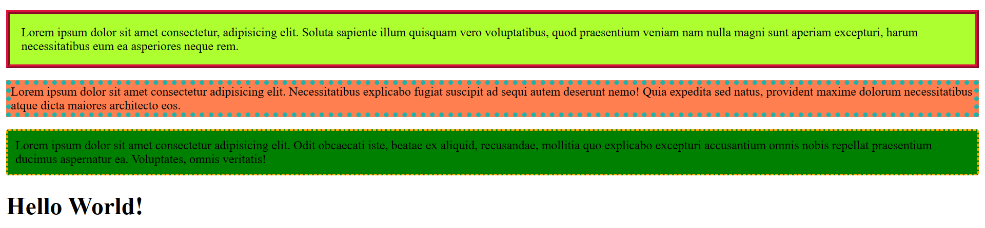

**ii) Internal or Embedded CSS :-**

**This can be used when a single HTML document must be styled uniquely. The CSS rule set should be within the HTML file in the head section i.e the CSS is embedded within the HTML file.**

**Example:**

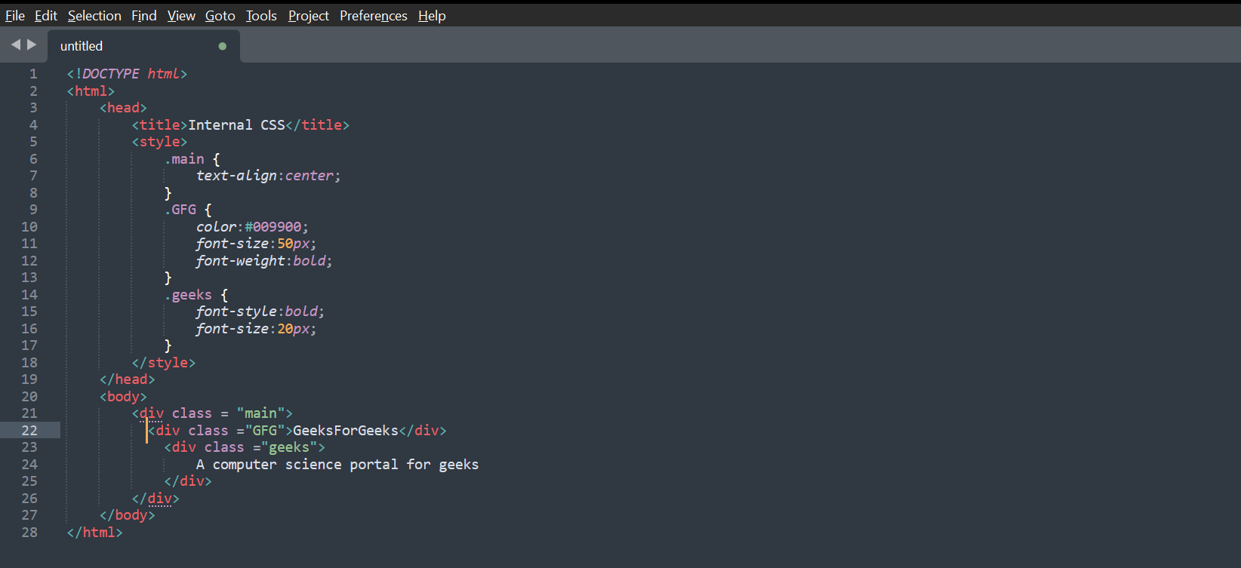

**Output:**

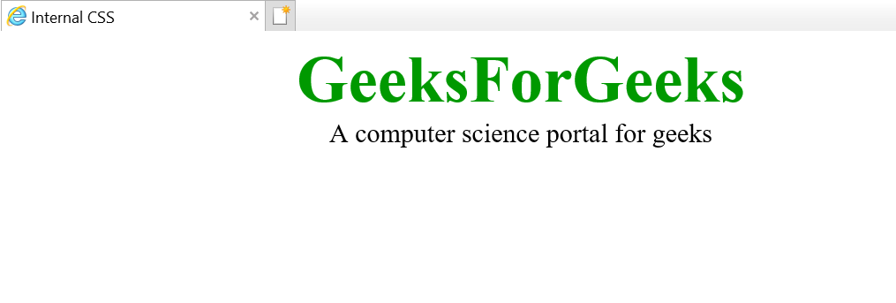

**iii) External CSS:-**

**External CSS contains separate CSS file which contains only style property with the help of tag attributes (For example class, id, heading, etc). CSS property written in a separate file with .css extension and should be linked to the HTML document using link tag. This means that for each element, style can be set only once and that will be applied across web pages.**

**Example:**

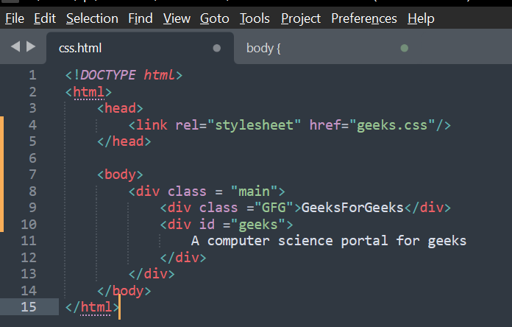

**The file given below contains CSS property. This file save with .css extension. For Ex: geeks.css**

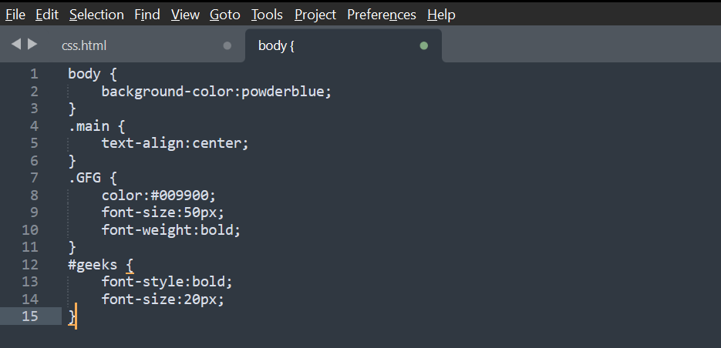

**Output:**



**2.** **What are the disadvantages of CSS ?**

**Ans:-**

1. **CSS, CSS1 up to CSS3, result in creating of confusion among  web browsers.**
2. **With CSS, what works with one browser might not always work with another. The web developers need to test for compatibility, running the program across multiple browsers.**
3. **There exists a scarcity of security.**
4. **After making the changes we need to confirm the compatibility if they appear. The similar change affects on all the browsers.**
5. **The programing language world is complicated for non-developers and beginners. Different levels of CSS i.e. CSS, CSS 2, CSS 3 are often quite confusing.**
6. **Browser compatibility (some styles sheet are supported and some are not).**
7. **CSS works differently on different browsers. IE and Opera supports CSS as different logic.**
8. **There might be cross-browser issues while using CSS.**
9. **There are multiple levels which creates confusion for non-developers and beginners.**

**3.** **What is the difference between CSS2 and CSS3?**

**Ans:-** **Cascading Style Sheets or CSS manage the complete computing machine designing with one-click changes. the latest version of CSS is that the CSS3 version primarily differs from CSS2 at intervals the incorporation of Modules and completely different changes. Modules modify the look to be tired a lesser time with further ease whereas modification individual choices and specifications. The CSS3 version supports a lot of browsers than CSS2, but check that to ascertain it on all operating systems and browsers.**

* **Differences between CSS3 and CSS2:**
  1. **CSS3 is split into many various documents known as Modules. each module adds new capability or extends options outlined in CSS2 over conserving backward compatibility. Work on CSS3 started around the time of publication of the initial CSS2 recommendation.**
  2. **The CSS3 version supports more browsers than CSS2.**
  3. **CSS3 introduces several new selectors. Those new selectors square measure largely in an exceeding type of pseudo-elements and pseudo-categories.**
  4. **The new addition of General relation Combinator will be wont to match relation parts of a given part through diacritic (~) combinatory.**
  5. **CSS3 introduces several properties attended with new values and units. It facilitates styling of backgrounds, borders, boxes, etc…, that permits the USA to stay most of the styling at intervals the computer network and HTML standards and our document, while not a necessity for all those proprietary third-party package packages.**

**4.** **Name a few CSS style components ?**

**Ans :-**

1. **Selector: class name, id name or element name that is target**
2. **Attribute: name of the attribute you want to style for example border, color, background, position etc.**
3. **Value of Property: value that will be assigned to attribute.**

* **p is selector, following style rules will be applied to allparagraph.**

1. **color is attribute and value is red.**
2. **position is another attribute with value relative.**
3. **text-align is last attribute with value left.**

**Example:** 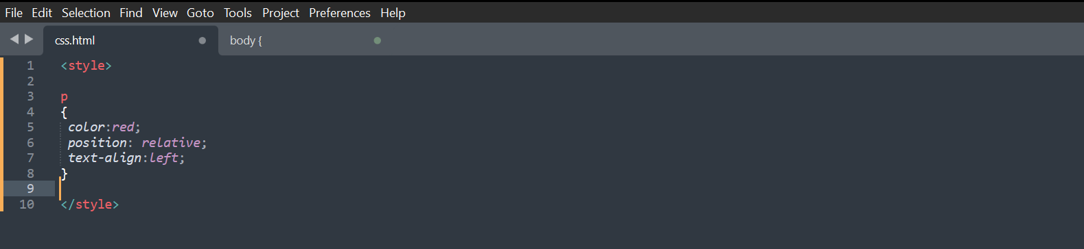

**Output:**

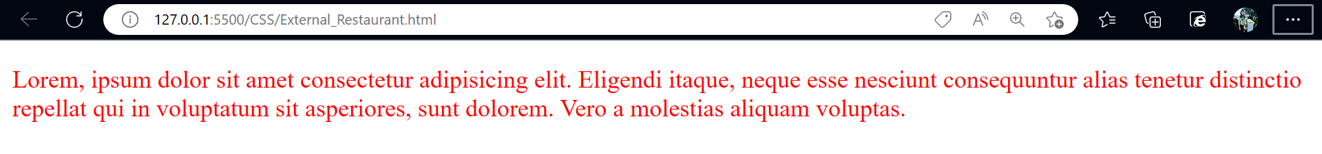

**5. What do you understand by CSS opacity ?**

**Ans:-** **The opacity CSS property sets the opacity of an element. Opacity is the degree to which content behind an element is hidden, and is the opposite of transparency. opacity applies to the element as a whole, including its contents, even though the value is not inherited by child elements. Thus, the element and its children all have the same opacity relative to the element's background, even if they have different opacities relative to one another.**

**Example:**

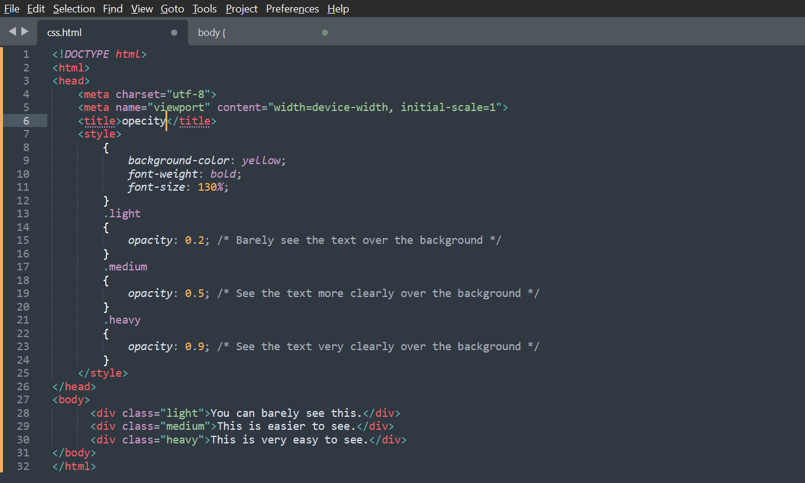

**Output:**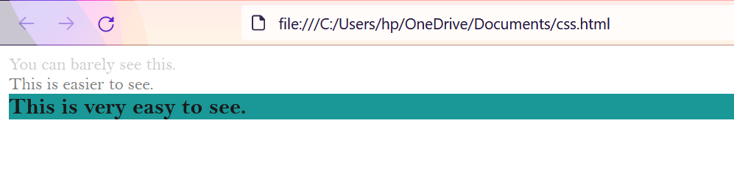

**6.** **How can the background color of an element be changed ?**

**Ans:-** **To add background color in HTML, use the CSS background-color property. Set it to the color name or code you want and place it inside a style attribute. Then add this style attribute to an HTML element, like a table, heading, div, or span tag.**

**Example:**

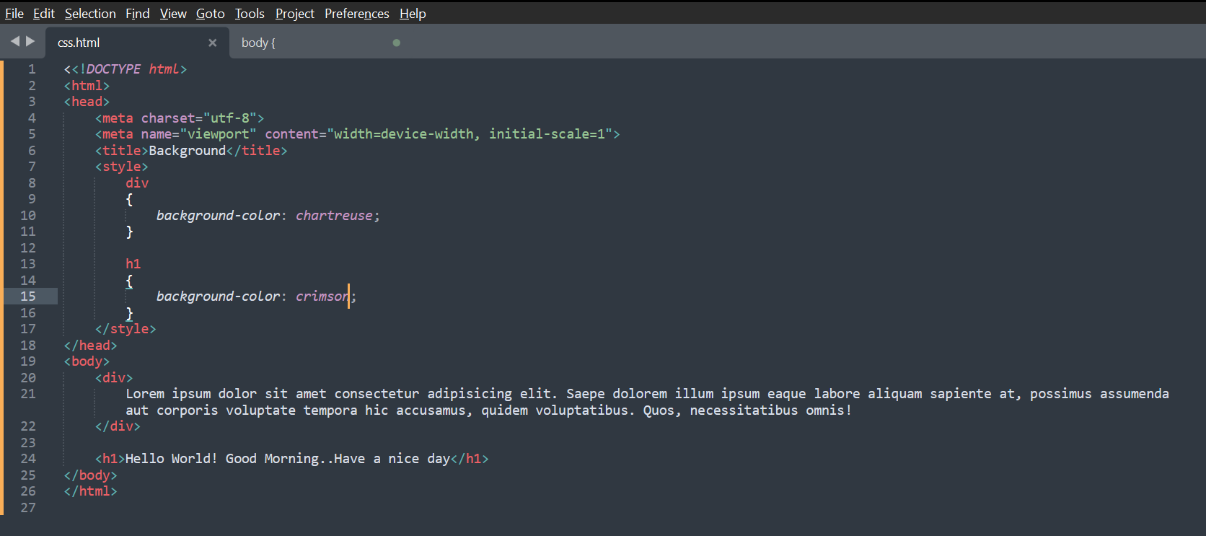

**Output:**

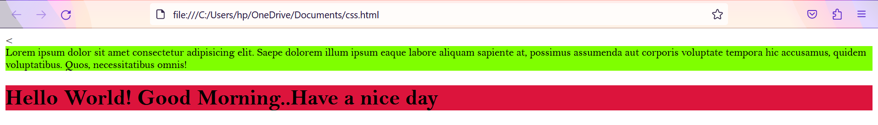

**7.** **How can image repetition of the backup be controlled ?**

**Ans:-** **This task can be achieved by using the *background-repeat property* that will help us to control the repetition of the image. The background-repeat property in CSS is used to repeat the background image both horizontally and vertically. It also decides whether the background image will be repeated or not.**

**Example:**

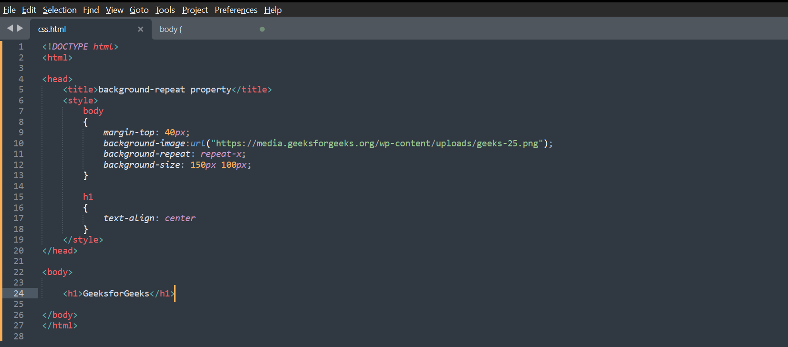

**Output:**

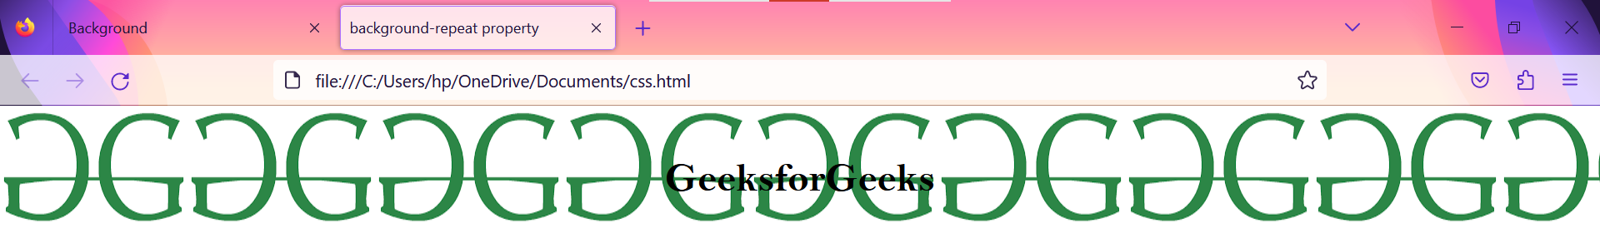

**8.** **What is the use of the background-position property?**

**Ans:-** **The** **background-position property in CSS is mainly used to sets the initial position for the background image Ie., it is used to set an image at a certain position. The position that is relative to the positioning layer, can be set by using the background-origin property. Syntax: background-position: value; Note: The background-image is placed default to the top-left corner of an element with a repetition on both horizontally & vertically.**

**Example:**

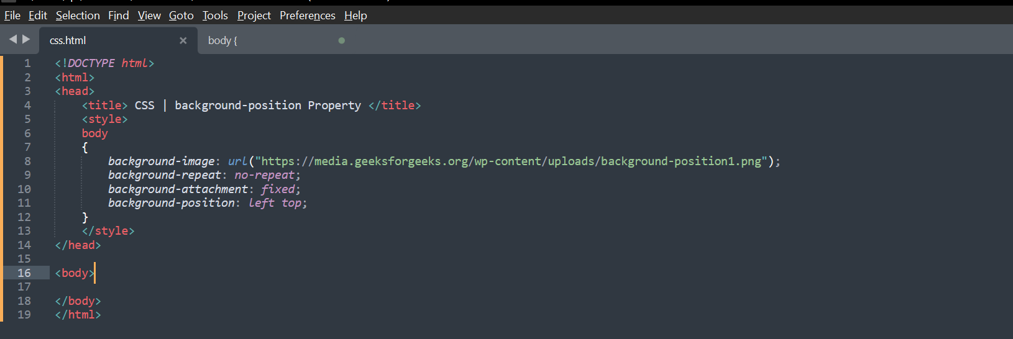

**Output:**

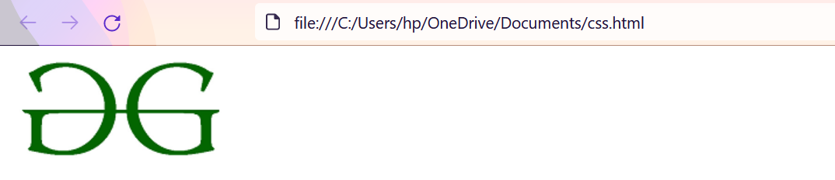

**9.** **Which property controls the image scroll in the background?**

**Ans:** **-**

**The**[***background-attachment***](https://www.geeksforgeeks.org/css-background-attachment-property/)**property in CSS is used to specify the kind of attachment of the background image with respect to its container. It can be set to scroll or make it remain fixed. It can be applied to all**[**HTML**](https://www.geeksforgeeks.org/html/)**elements.**

**Example:**

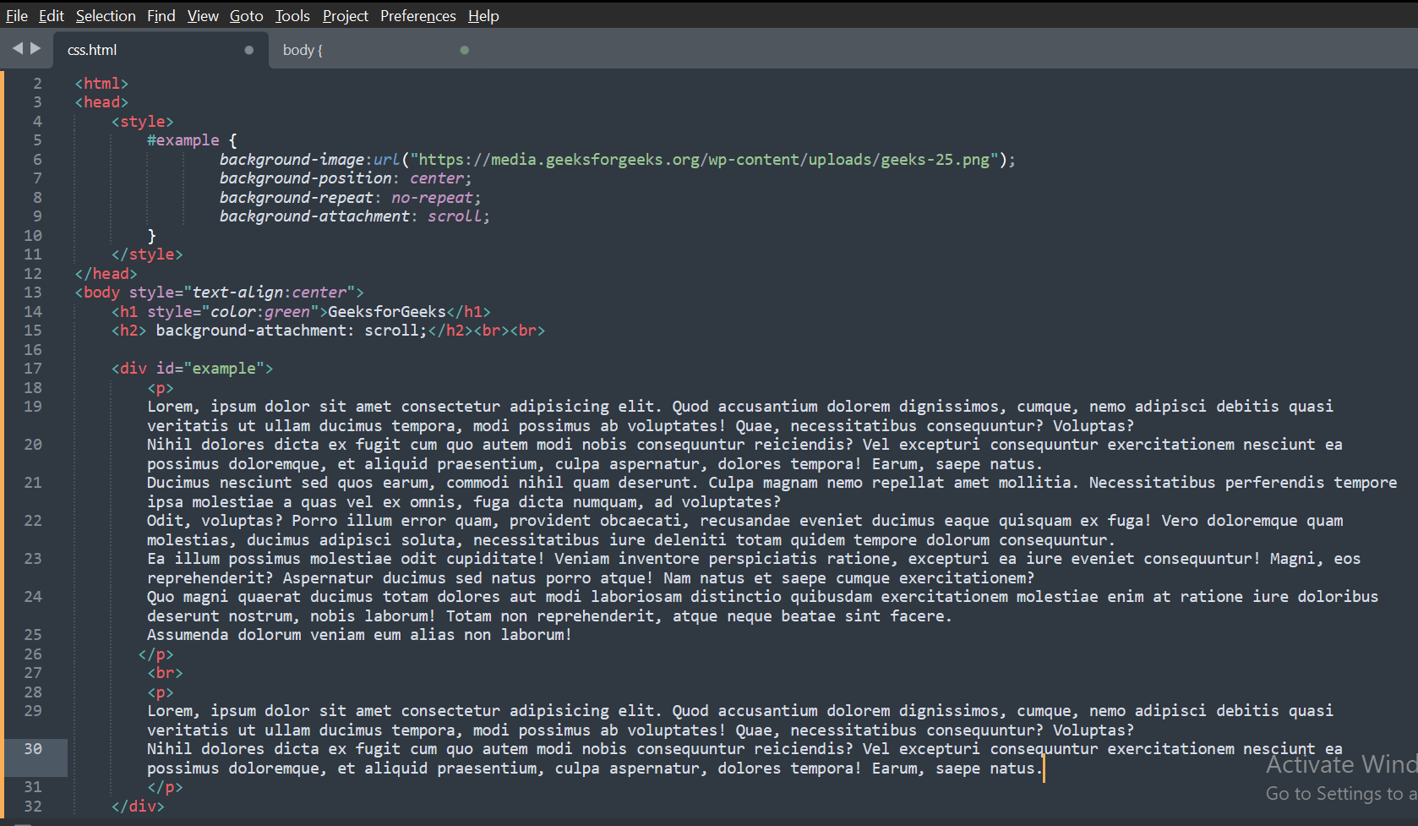

**Output:**

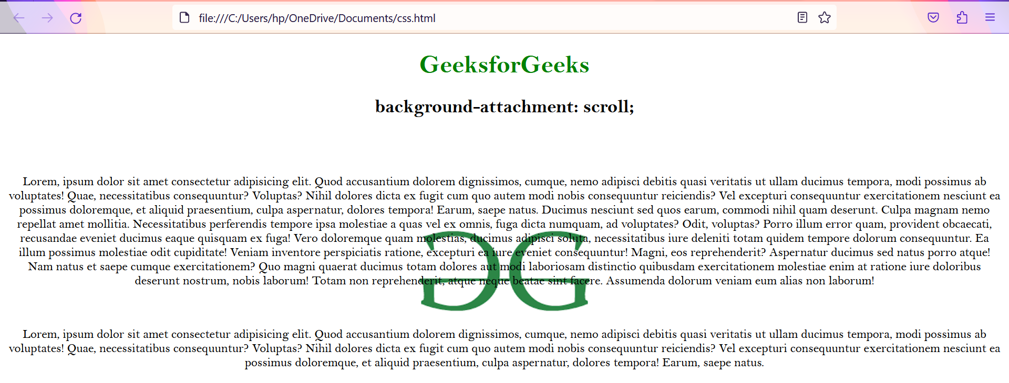

**10.** **Why should background and color be used as separate properties?**

**Ans:-**

* **It enhances the legibility of style sheets. The background property is a complex property in CSS, and if it is combined with color, the complexity will further increase.**
* **Color is an inherited property while the background is not. So this can make confusion further.**

**Example:**

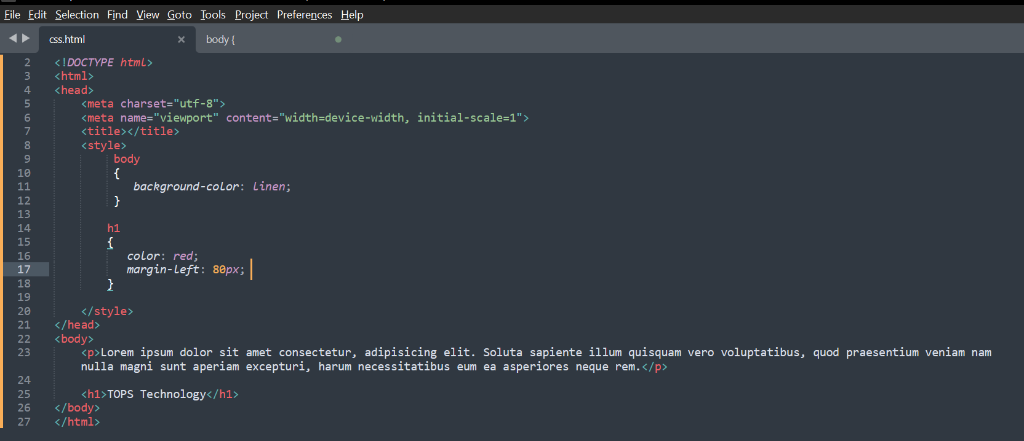

**Output:**

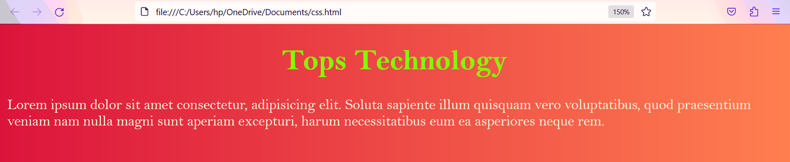

**11.** **How to center block elements using CSS1?**

**Ans:-**

**Step 1: Define the external width – We need to define the external width. Block-level elements have the default width of 100% of the webpage, so for centering the block element, we need space around it. So for generating the space, we are giving it a width.**

**Step 2: Set the left-margin and the right-margin of the element to auto – Since we produced a remaining space by providing external width so now we need to align that space properly that’s why we should use margin property. Margin is a property that tells how to align a remaining space. So for centering the element you must set left-margin to auto and right-margin to auto.**

**Example:**

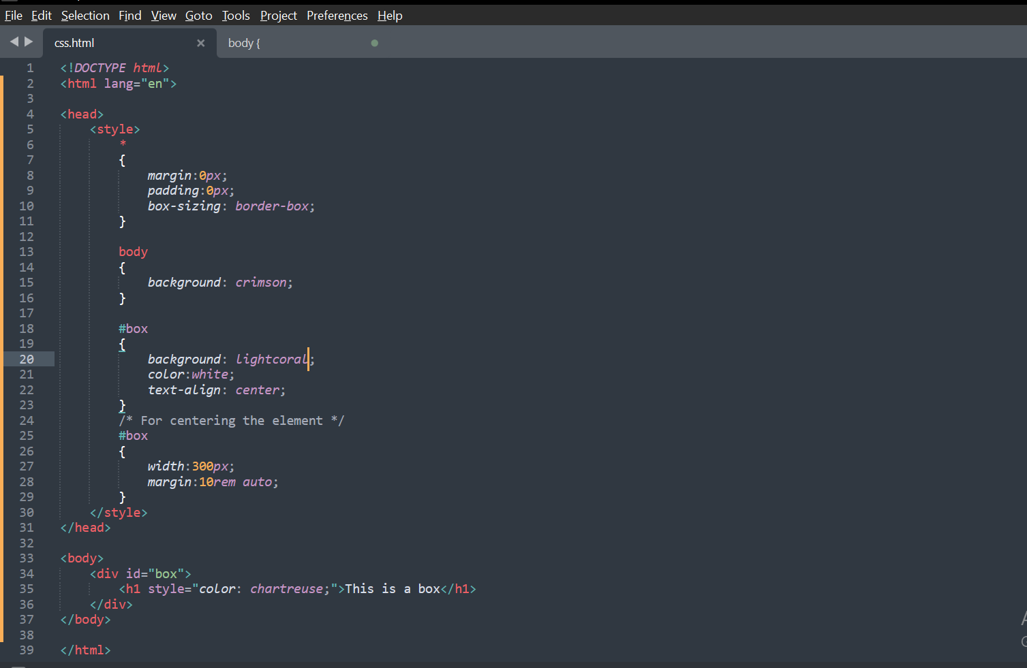

**Output:**



**12.** **How to maintain the CSS specifications?**

**Ans:-** **If you've followed this series from the beginning , we discussed about the**[**HTML Specification**](https://dev.to/ziizium/the-html-specification-4epa)**which is sort of a rule book that tells browser vendors how to implement HTML Elements and Tags. The CSS Specification is no different but with a different approach with the advent of CSS3.The Specification defines how CSS properties should be implemented by browser vendors along with detailed algorithms, code samples and tabular information.**

* **The Specification also include :-**
* **The syntax and data types of the language.**
* **Detailed explanation on CSS Selectors.**
* **How you can assign values to properties.**
* **The Cascade (the "C" in CSS).**
* **How inheritance works.**
* **The Box Model etc.**

1. **Explanation on some of these topic are short and easy to understand while others are explained in great detail.**
2. **The Specification also specify how stylesheets can be included in your web document and how to target specific media e.g print or screen.**
3. **The CSS Specification prior to CSS3 was a single Specification**, **CSS3 on the other hand** **is divided into Modules which are Independent Specifications that can be worked on by different author(s) at different paces, that's why we have Selector Level 3 Specification, CSS Color 4, CSS Backgrounds and so on. Some of these modules are revisions of CSS2.1, and some are newly created, but all fall under the banner of CSS3.**
4. **The Specification should be your guide if you need to understand how a specific property or feature works behind the scene and how it works with other CSS properties. And if you are comfortable reading algorithms you won't get bored reading the CSS Specification.**
5. [**The Specifications can be accessed online**](https://drafts.csswg.org/)**along with the author(s) name and when it was last updated.**
6. **Take your time and familiarize yourself with the Specification because we will be making heavy use of it in the topic: CSS Selectors.**

**13.** **What are the ways to integrate CSS as a web page?**

**Ans:-**

* **They are three way to integrate CSS into a web page.**

1. **Inline - by using the style attribute inside HTML elements.**
2. **Internal - by using a <style> element in the <head> section.**
3. **External - by using a <link> element to link to an external CSS file.**

**Example:**

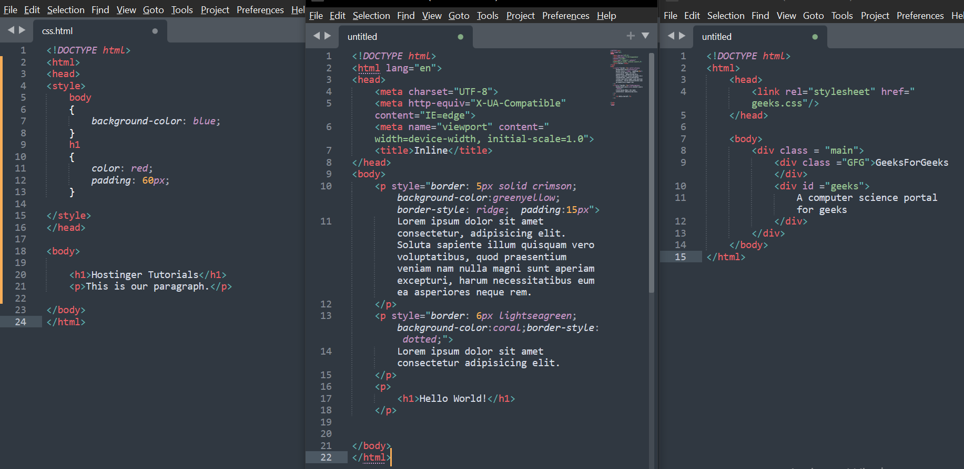

**Output:**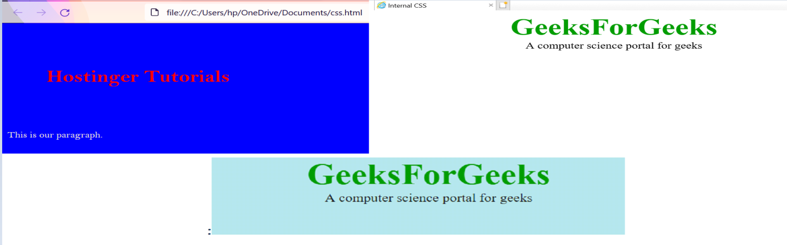

**14.** **What is embedded style sheets?**

**Ans:-** **Embedded StyleSheet -:It allows you to define styles for a particular HTML document as a whole in one place. This is done by embedding the <style>_</style>** **tags containing the CSS properties in the head of your document. Embedded style sheets are particularly useful for HTML documents that have unique style requirements from the rest of the documents in your project.**

**Example:**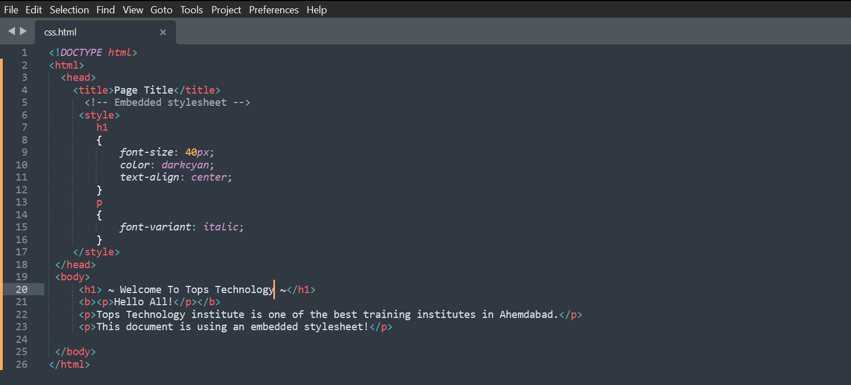

**Output:**

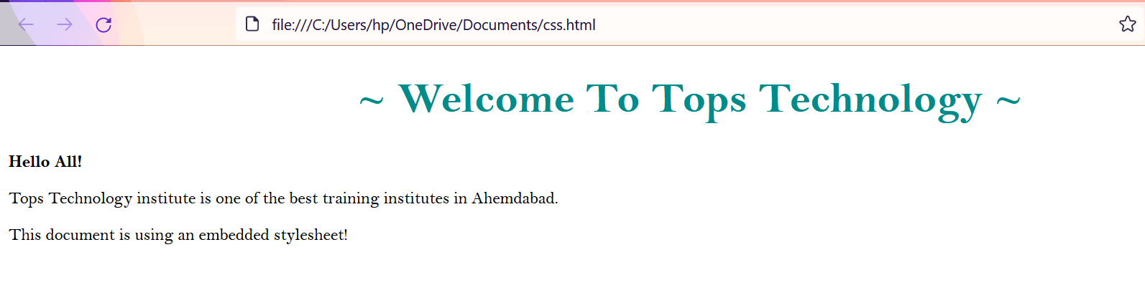

**15.** **What are the external style sheets?**

**Ans:-** **To apply a rule to multiple pages, an external style sheet is used. An external style sheet is a separate CSS file that can be accessed by creating a link within the head section of the webpage. Multiple webpages can use the same link to access the stylesheet.The link to an external style sheet is placed within the head section of the page.**

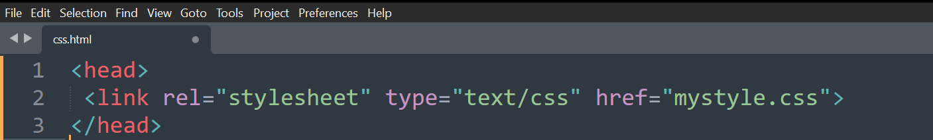

**The actual style sheet file will contain CSS rules that are then applied across the entire page.**

**For example:**

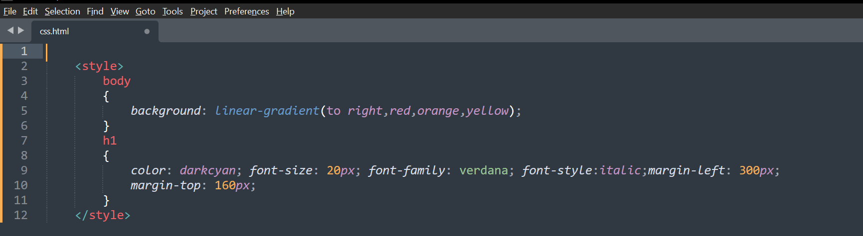

**Output:**



**16.** **What are the advantages and disadvantages of using external style sheets?**

**Ans:-**

* **The advantages of External Style Sheets are:  
    
  i. Using them, the styles of multiple documents can be controlled from one file.   
  ii. Classes can be created for use on multiple HTML element types in many documents.   
  iii. In complex situations, selector and grouping methods can be used to apply styles.**
* **The disadvantages of External Style Sheets are:  
    
  i. In order to import style information for each document, an extra download is needed.   
  ii. Until the external style sheet is loaded, it may not be possible to render the document.   
  iii. For small number of style definitions, it is not viable.**

**17.** **What is the meaning of the CSS selector?**

**Ans:- A CSS selector is the first part of a CSS Rule. It is a pattern of elements and other terms that tell the browser which HTML elements should be selected to have the CSS property values inside the rule applied to them. The element or elements which are selected by the selector are referred to as the subject of the selector.**

**Example:**

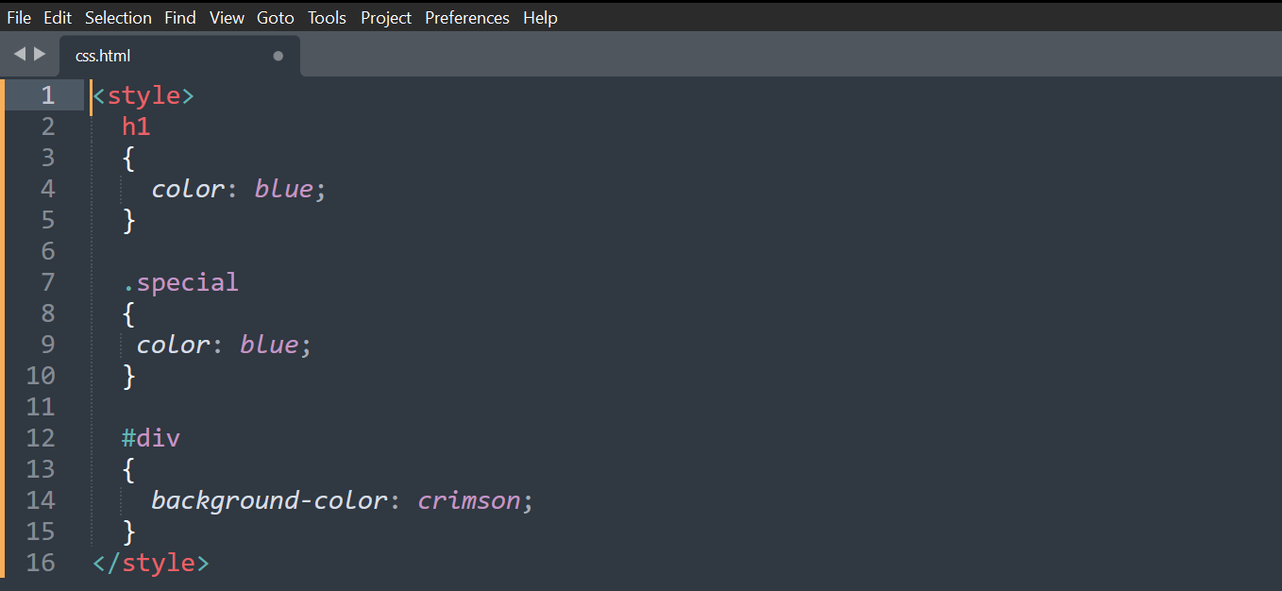

**18.** **What are the media types allowed by CSS?**

**Ans:-** **One of the most important features of style sheets is that they specify how a document is to be presented on different media: on the screen, on paper, with a speech synthesizer, with a braille device, etc.**

**We have currently two ways to specify media dependencies for style sheets −**

* **Specify the target medium from a style sheet with the @media or @import at-rules.**
* **Specify the target medium within the document language.**

**The @media rule:- An *@media* rule specifies the target media types (separated by commas) of a set of rules.**

**Example:**

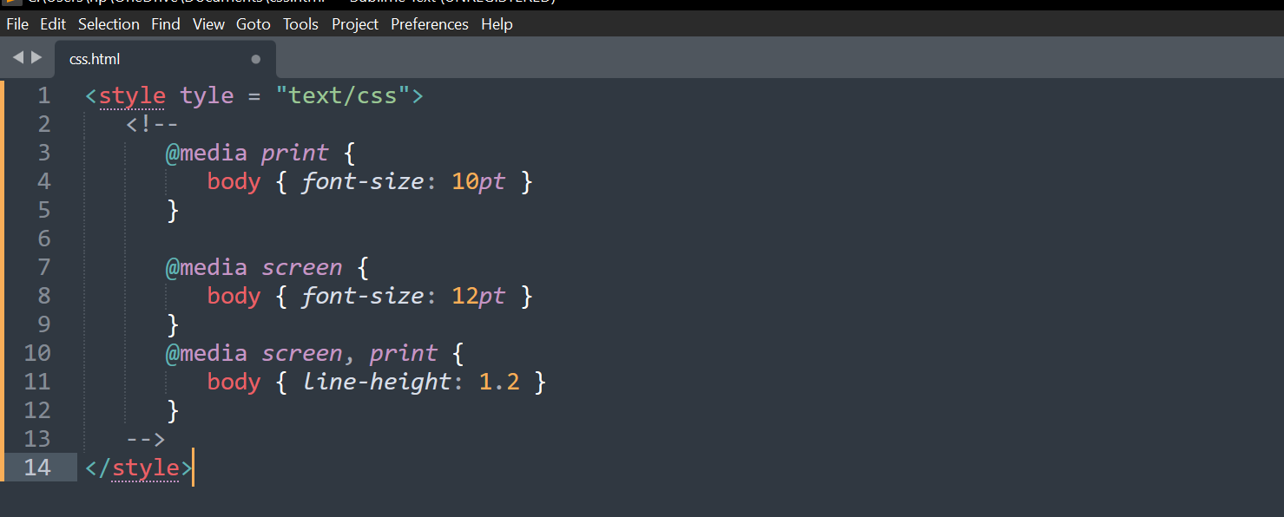

**19.** **What is the rule set?**

**Ans:-** **CSS allows this by associating conditions with declarations blocks. Each (valid) declaration block is preceded by one or more comma-separated**[**selectors**](https://developer.mozilla.org/en-US/docs/Web/CSS/CSS_Selectors)**, which are conditions selecting some elements of the page. A**[**selector group**](https://developer.mozilla.org/en-US/docs/Web/CSS/Selector_list)**and an associated declarations block, together, are called a ruleset, or often a rule.**

**A CSS ruleset (or rule) is visualized in the diagram below:**

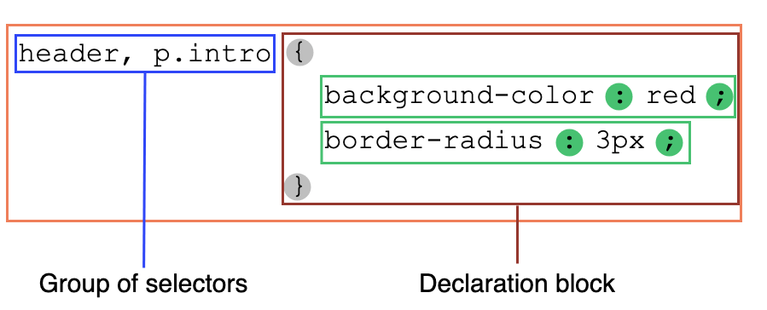

**20.** **Create Layouts.**

**Ans:-** 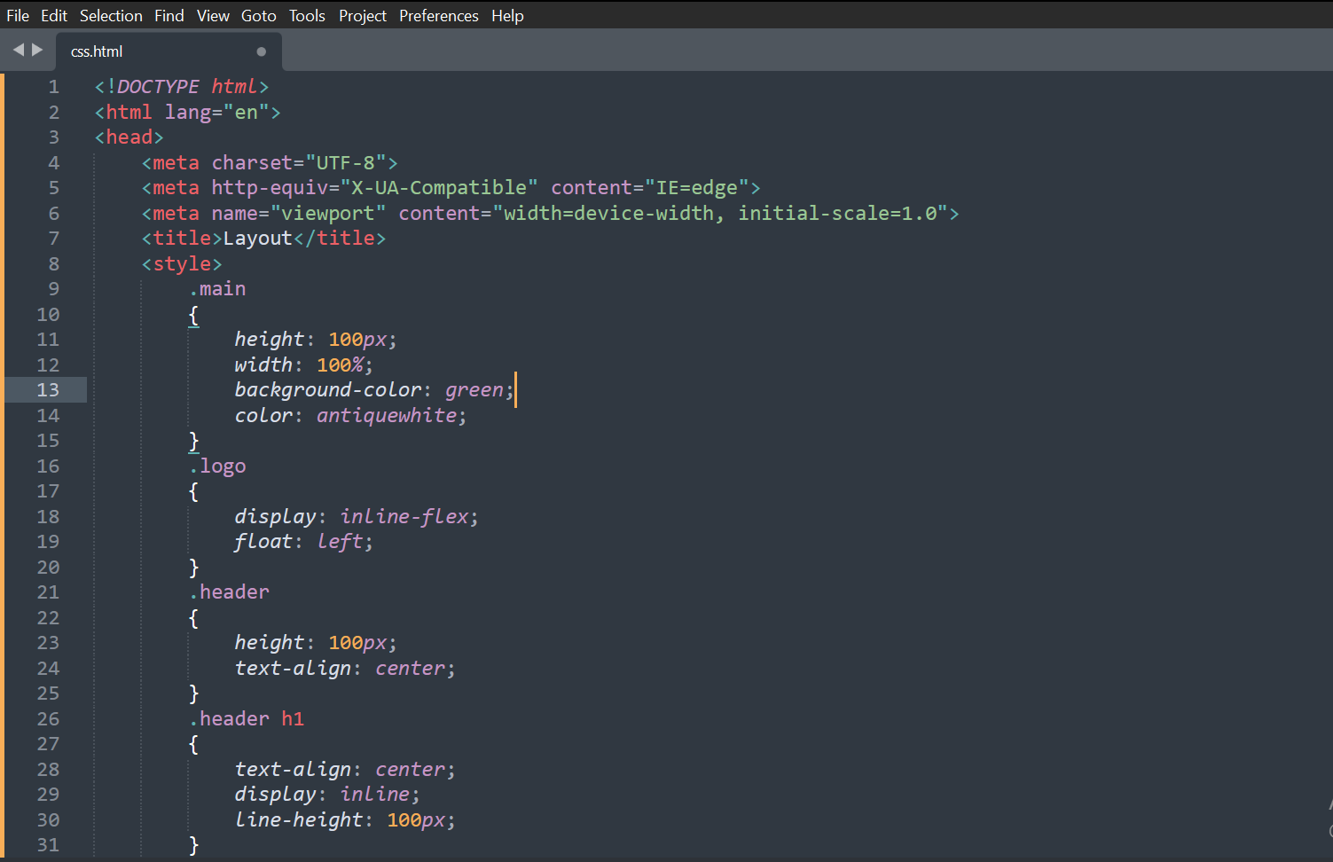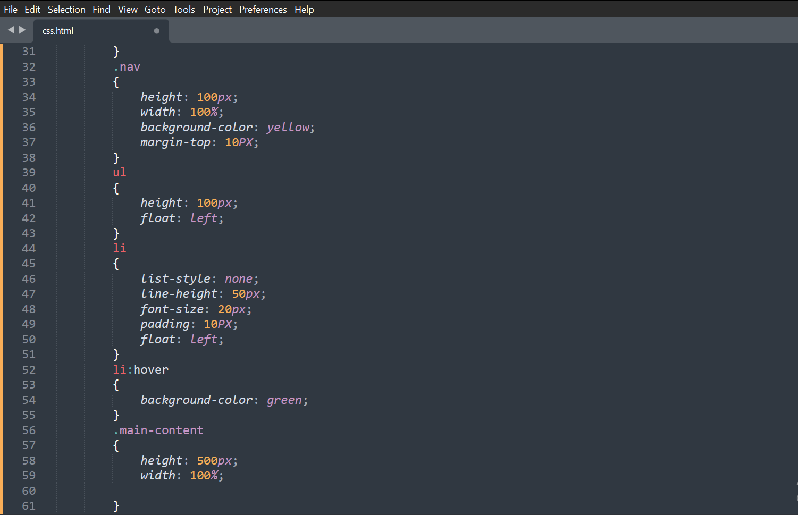

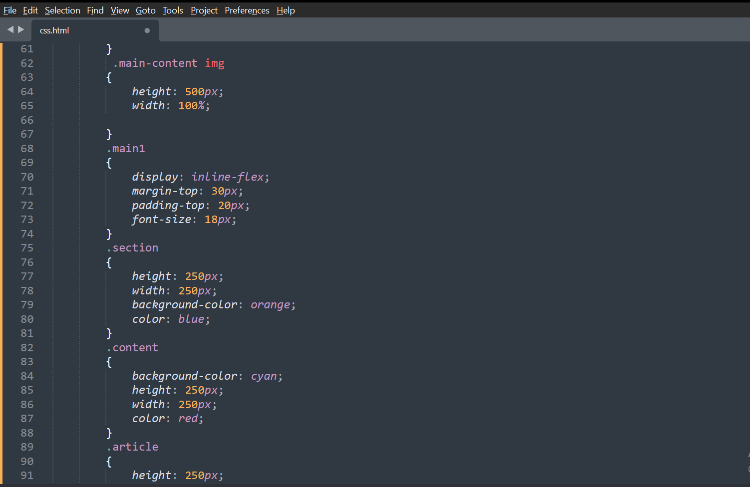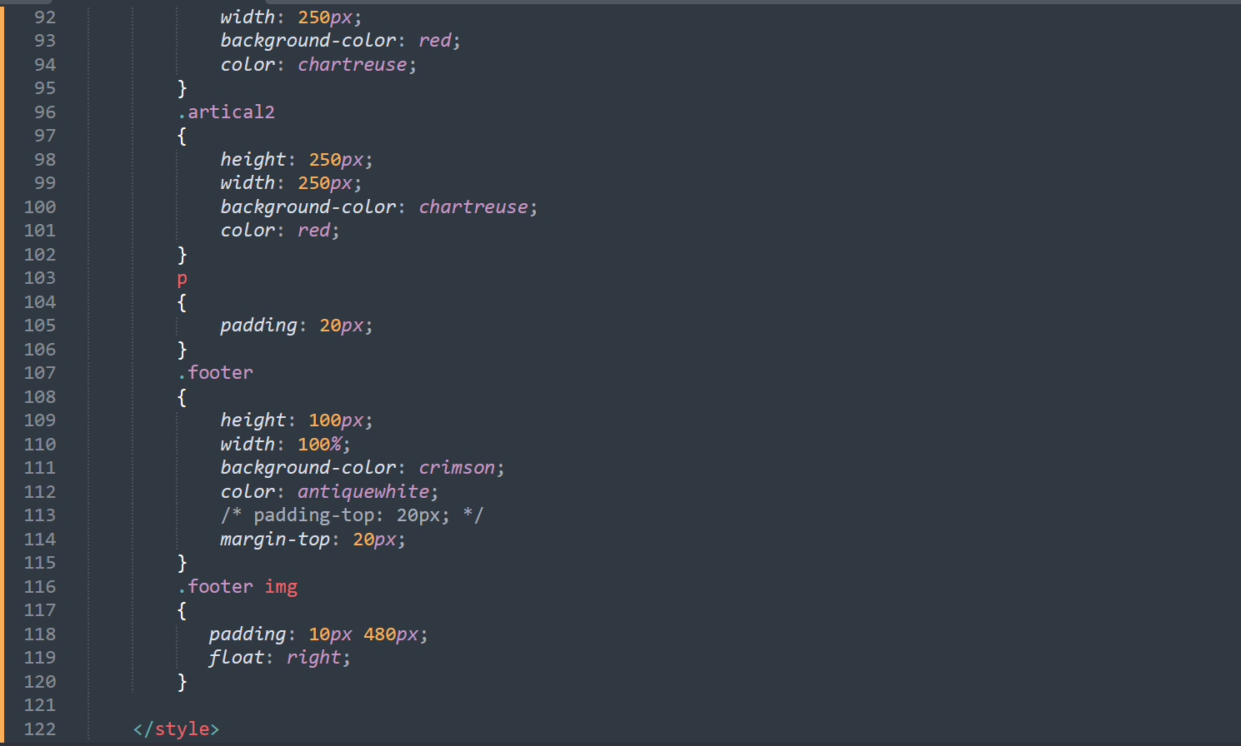

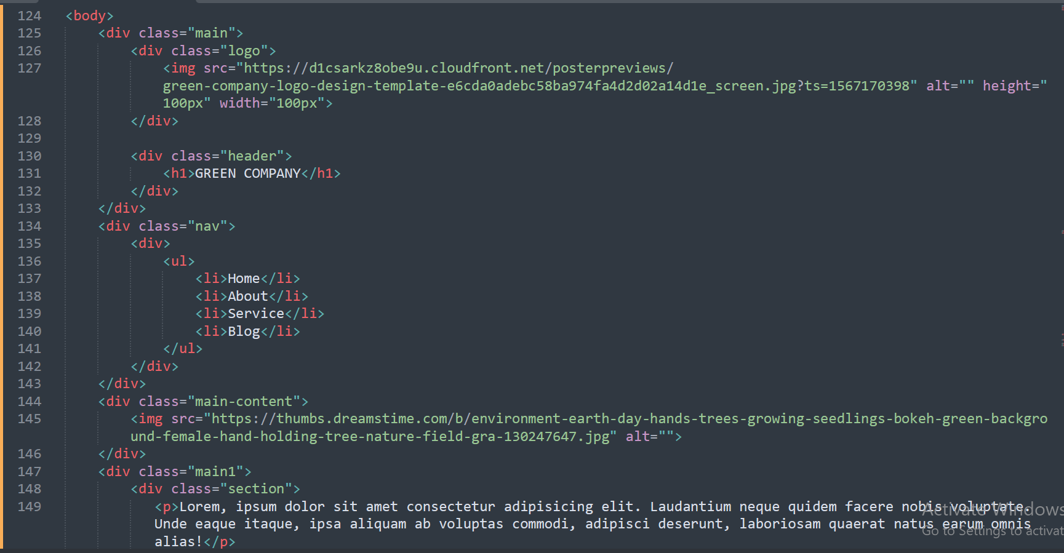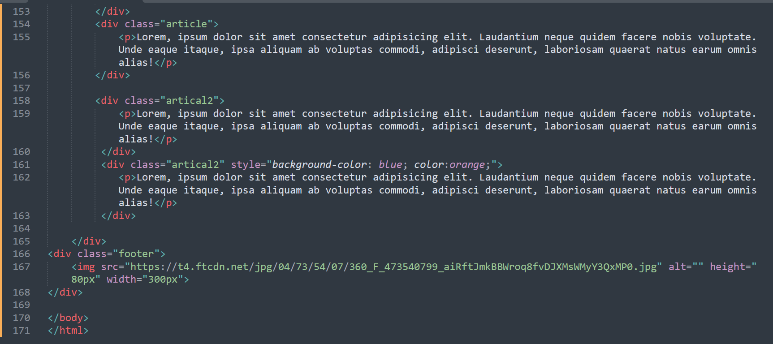

**Output:**

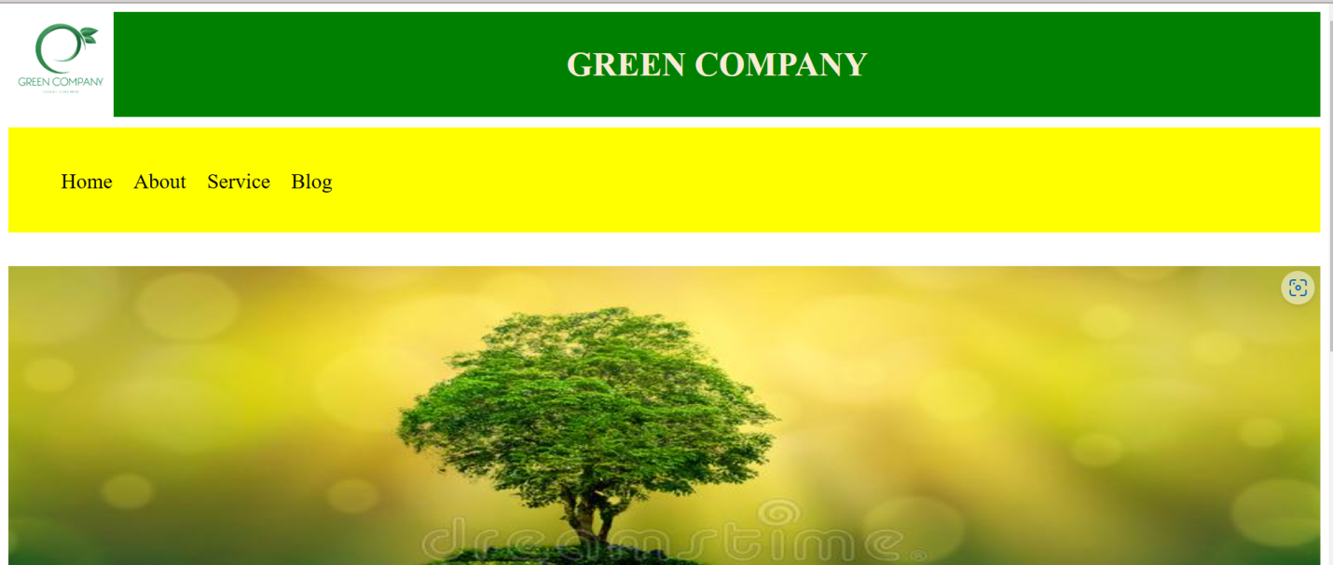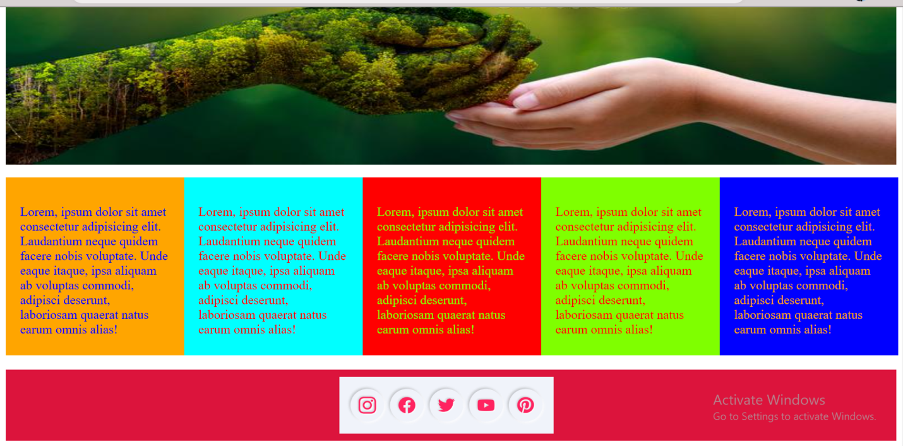

**---- xoxoxoxox ----**